Fulltext Title
Presenting/corresponding author name
Co-author, supervisor
Brno Univerzity of Technology,
Faculty of Chemistry,
Institute of Physical chemistry
Purkyňova 464/118, 612 00 Brno, Czech Republic
Author email
1 Introduction
Photocatalytically active layers are becoming increasingly important. These products are used in a wide range of applications. In particular, they serve as decomposers of organic molecules, where undesirable pollutants can be decomposed into simple and harmless substances such as water and carbon dioxide. Another important application is the disinfection of air or water, where photocatalytically active particles or layers destroy bacteria, viruses and fungi¹.
Chemical and mechanical resistance is an important parameter in addition to the efficiency of the photocatalytically active layers. The release of the photocatalyst into the environment causes problems that reduce the efficiency of the layers but can also adversely affect the environment from an environmental point of view¹, ².
2 Experimental
2.1 Synthesis of polysiloxane condensates
The first phase of the work is the synthesis of polysiloxane condensates (organosilica binders). The synthesis of polysiloxane condensates is based on the acid hydrolysis of the organosilica precursor. Three types of organosilica precursor were selected: methyltriethoxysilane (MTEOS), propyltriethoxysilane (PrTEOS) and phenyltriethoxy-silane (PhTEOS). As a standard, a binder marked SiBi-0 is used, where MTEOS is hydrolysed at pH in the range of 3-3.5⁶. This synthesis is time-consuming, therefore the synthesis proceeded at pH = 1⁷. This process has economic advantages such as energy savings and time savings, and the absence of organic solvents required for the first synthesis. The resulting products synthesized at pH = 1 carry marks SiBi-1 for precursor MTEOS, PrSiBi-1 for precursor PrTEOS, PhSiBi-1 for precursor PhTEOS.
Figures 1-4 show all the syntheses used in this work.
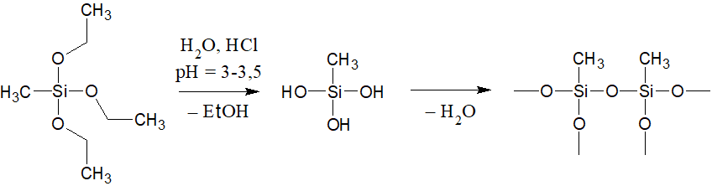
Figure 1: synthesis of SiBi-0 from MTEOS
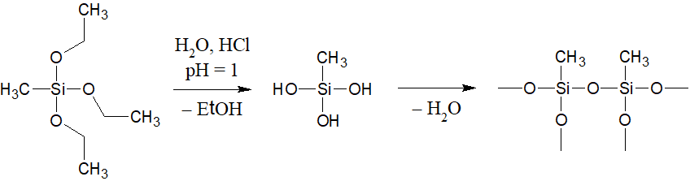
Figure 2: synthesis SiBi-1 from MTEOS
2.1 FT-IR of polysiloxane condensates
The FT-IR method gave an initial picture of the composition of the synthesized polysiloxanes. The prepared polysiloxanes should contain an organic residue which should be evident in the FT-IR spectrum.
Figure 5 shows a sample of SiBi-0 and SiBi-1. Both samples have methyl residues, as evidenced by a peak of about 2 950 cm−1 and a small bump in the region of 2 895-2 840 cm−1. The area around 3 600-3 000 cm−1 most likely contains mainly Si−OH, H2O, terminal hydroxyl groups and other hydroxyl-like groups.
SiBi-0 is a standard that we try to replace with SiBi-1 because SiBi-1 is much more economical for synthesizing. The results from FT-IR show that both syntheses could be interchangeable in terms of chemical composition of the products.
The PrSiBi-1 sample is based on a propyl-containing precursor. This is reflected by the spectrum recorded in figure 6. The range from 2 995 cm−1 to 2 835 cm−1 most likely reflects the occurrence of −CH3 terminal carbons and −CH2− internal carbons contained in propyl.
The last sample was phenylated PhSiBi-1. The presence of phenyl is shown by peaks in the region of 3 100-3 000 cm−1, which is confirmed by the four peaks in the region of 2 000-1 750 cm−1. Figure 7 shows spectrum of this sample.
3 Results and Discussion
We managed to synthesize four types of polysiloxane condensates, SiBi-0 has been studied for many years and serves as a standard and we introduced three new types using a different synthesis procedure. SiBi-1 appears to be the improvement that could replace SiBi-0. Thermal analysis products are similar and the FT-IR spectrum shows the same compounds. In order to confirm the identity of both polysiloxanes, both binders will be further optimized.
PrSiBi-1 and PhSiBi-1 will serve for future matrix where it is expected that the length of the organic residue will significantly affect the properties of the matrix, such as the porosity of the layers of organosilica binder deposited with titanium dioxide on the desired substrate.
4 References
- FUJISHIMA, A., HASHAMITO, K., WATANABE, T.: TiO2 photocatalysis, Fundamentals and Applications, BKC, Inc. 1999, p. 197, ISBN 4-969051-03-X.
- ZHAO, C., M. PELAEZ, D. D. DIONYSIOU, S. C. PILLAI, J. A. BYRNE a K. E. O’SHEA. UV and visible light activated TiO2 photocatalysis of 6-hydroxymethyluracil, a model compound for the potent cyanotoxin cylindrospermopsin. Catalysis Today. 2014, n. 224, p. 70-76.
- VERMA, J., S. NIGAM, S. SINHA a A. BHATTACHARYA. Development of polyurethane based anti-scratch and anti-algal coating formulation with silica-titania core-shell nanoparticles. Vacuum. 2018, (153), 24-34.
- BAKLANOV, M. R., J. F. DE MARNEFFE, D. SHAMIRYAN, A. M. URBANOWICZ a H SHI. Plasma processing of low-k dielectrics. JOURNAL OF APPLIED PHYSICS. 2013, n. 113, p. 041101-1-041101-41. DOI: 10.1063/1.4765297.
- KIM, H. a T. HWANG. Mixed binder of silica nanoparticles and titanium isopropoxide for low-temperature cured titanium oxide photoanode of dye-sensitized solar cell. Journal of Sol-Gel Science and Technology. 2014, n. 74, p. 143–150. DOI: 10.1007/s10971-014-3588-x.
- GRÉGORI, D., I. BENCHENAA, F. CHAPUT, S. THÉRIAS, J.-L. GARDETTE, D. LÉONARD, C. GUILLARD a S. PAROLA. Mechanically stable and photocatalytically active TiO2/SiO2 hybrid films on flexible organic substrates. Journal of Materials Chemistry A. 2014, p. 20096–20104. DOI: 10.1039/c4ta03826f.
- ESTELLA, J., D. WENCEL, J. P. MOOR, M. SOURDAINE a C. MCDONAGH. Fabrication and performance evaluation of highly sensitive hybrid sol–gel-derived oxygen sensor films based on a fluorinated precursor. Analytica Chimica Acta. 2010, 666, 83-90.

